DATA SCIENCE WITH PYTHON INTERNSHIP
WEEK 2 TASK

Exploratory Data Analysis and Visualization
Patterns in disease progression among 442 diabetes patients

Submitted by | SIVASHANKARI S
Programme | Data Science with Python - Internship
Task | Week 2 Task
Dataset | Diabetes dataset (Efron et al., 2004) - 442 patients, 10 baseline variables
Tools | Python 3, Pandas, NumPy, Matplotlib, Seaborn, Scikit-learn
Date | 20 October 2026

Table of Contents
1. Introduction and Objectives
2. Dataset and Approach
3. Initial Analysis and Summary Statistics
4. The Target Variable
5. Distributions of the Predictors
6. Outliers
7. Feature Transformations and Groupings
8. Correlation Analysis
9. Relationships and Scatter Plots
10. Multivariate View
11. Group Comparisons and Aggregations
12. Two-Factor Interaction
13. Statistical Testing
14. Lipid Measurements
15. Key Insights
16. Limitations
17. Conclusion
18. References

1. Introduction and Objectives
Exploratory Data Analysis (EDA) is the stage where a data scientist learns what the data is saying before any model is built. Its aim is to summarise the main characteristics of a dataset, discover patterns and anomalies, check assumptions and generate hypotheses. This report applies EDA to a public medical dataset using Pandas for summaries, Matplotlib and Seaborn for visualisation and SciPy for statistical testing.
The central question guiding the analysis is: which patient measurements are associated with faster disease progression, and how strong and reliable are those associations?

2. Dataset and Approach
The data is the diabetes dataset first used by Efron, Hastie, Johnstone and Tibshirani in their 2004 paper on Least Angle Regression and distributed with scikit-learn. It contains 442 diabetes patients. For each patient, ten baseline measurements were recorded and the target is a quantitative measure of disease progression one year after baseline.
Table 1: Variables in the dataset
Column | Description
age | Age in years
sex | Sex of the patient, coded 1 or 2 in the source file
bmi | Body mass index
bp | Average blood pressure
tc | Total serum cholesterol (renamed from s1)
ldl | Low-density lipoproteins (s2)
hdl | High-density lipoproteins (s3)
tch | Total cholesterol / HDL ratio (s4)
ltg | Log of serum triglycerides (s5)
glu | Blood sugar level (s6)
progression | Disease progression one year after baseline (target)

The scikit-learn loader offers a standardised version of the features. The raw, unscaled version (scaled=False) was used so that axes show real units such as BMI and blood pressure, which makes charts interpretable. The data source does not document which numeric code stands for which sex, so the groups are labelled neutrally as 'Group 1' and 'Group 2' instead of guessing.
The workflow was: structure check, summary statistics, distribution analysis, outlier review, derived categories, correlation, bivariate and multivariate plots, group aggregation, statistical testing and interpretation.
Code 1: Libraries and plotting style
import os, numpy as np, pandas as pd
import matplotlib.pyplot as plt, seaborn as sns
from scipy import stats
from sklearn.datasets import load_diabetes

FIG = "figs"
os.makedirs(FIG, exist_ok=True)
sns.set_theme(style="whitegrid", font="DejaVu Sans")

Code 2: Loading and renaming the data
raw = load_diabetes(as_frame=True, scaled=False)
df = raw.frame.rename(columns={"s1": "tc", "s2": "ldl", "s3": "hdl",
"s4": "tch", "s5": "ltg", "s6": "glu",
"target": "progression"})
print("Shape:", df.shape)
print(df.head(6))

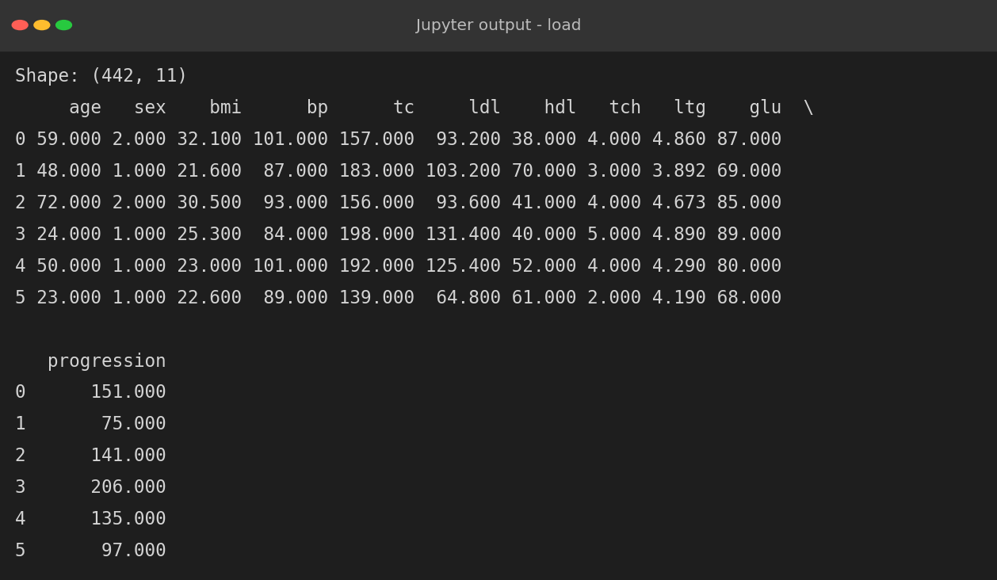
Figure 1: First rows of the dataset

3. Initial Analysis and Summary Statistics
Code 3: Data types, missing values and duplicates
print(df.dtypes.to_string())
print("\nMissing values:", int(df.isna().sum().sum()))
print("Duplicate rows:", int(df.duplicated().sum()))
print("Unique values in sex:", [int(v) for v in sorted(df["sex"].unique())])

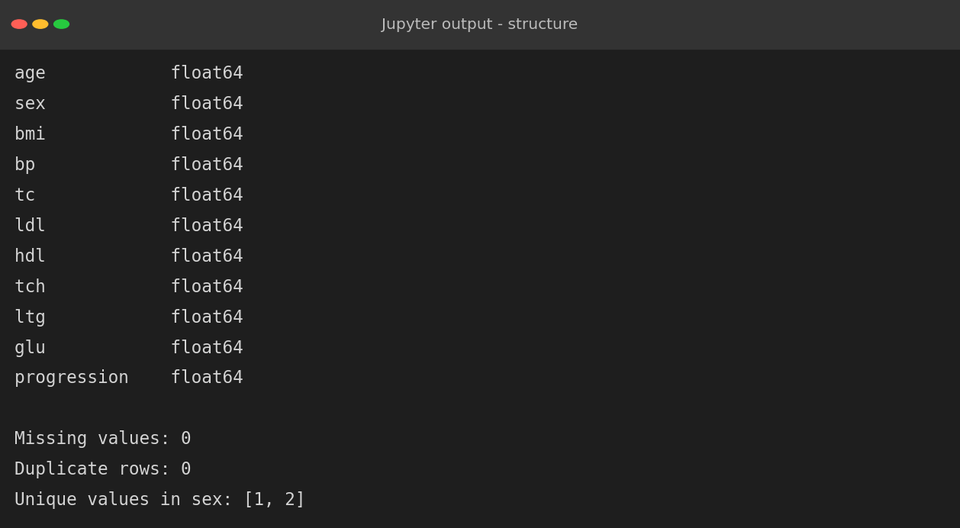
Figure 2: Structure and quality checks
All eleven columns are numeric, there are no missing values and no duplicate rows, so no cleaning was required. The sex column contains exactly two values.
Code 4: Summary statistics with skewness
desc = df.describe().T[["mean", "std", "min", "50%", "max"]]
desc["skew"] = df.skew()
print(desc.round(2))

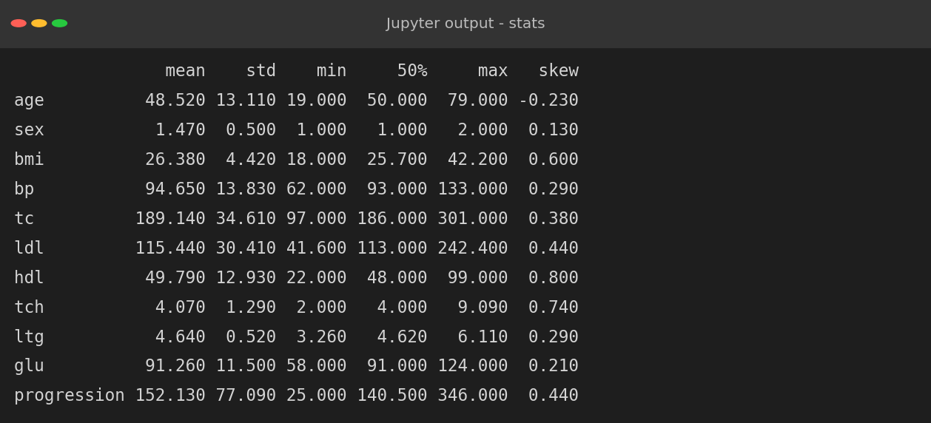
Figure 3: Descriptive statistics
Several observations come directly from the table:
- The average patient is 48.5 years old with a mean BMI of 26.4, which sits in the overweight range (25 to 30).
- The features are on very different scales (cholesterol around 189 versus triglyceride log around 4.6), which will matter for distance-based or regularised models later.
- All skewness values are below 1 in magnitude, so none of the variables is severely skewed. HDL (0.80) and the cholesterol ratio (0.74) have the longest right tails.
- Progression ranges from 25 to 346, with mean 152.1 and standard deviation 77.1, so patients differ widely in outcome.

4. The Target Variable
Code 5: Distribution and normality of the target
fig, ax = plt.subplots(1, 2, figsize=(12, 4.6))
sns.histplot(df["progression"], kde=True, bins=25, color="#4f81bd", ax=ax[0])
ax[0].axvline(df["progression"].mean(), color="red", ls="--", label="Mean")
ax[0].axvline(df["progression"].median(), color="green", ls=":", label="Median")
ax[0].set_title("Distribution of disease progression score")
ax[0].set_xlabel("Progression (1 year after baseline)"); ax[0].legend()
stats.probplot(df["progression"], dist="norm", plot=ax[1])
ax[1].set_title("Q-Q plot against the normal distribution")
plt.tight_layout(); plt.savefig(f"{FIG}/w2_target.png", dpi=150)
print("Mean :", round(df['progression'].mean(), 1))
print("Median :", df['progression'].median())
print("Skew :", round(df['progression'].skew(), 3))
print("Shapiro-Wilk p-value:", f"{stats.shapiro(df['progression']).pvalue:.2e}")

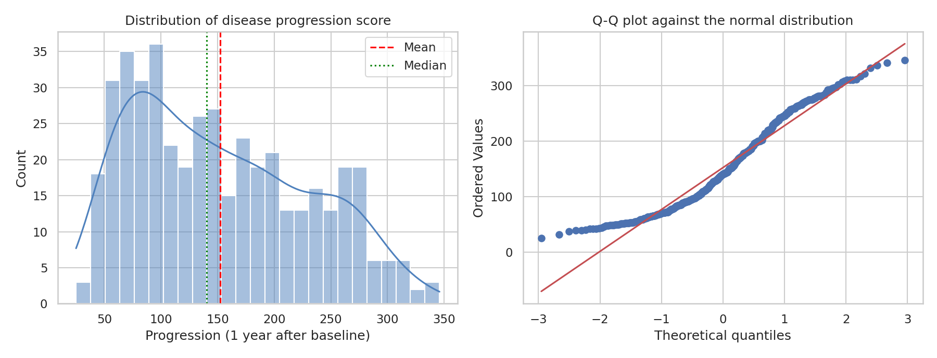
Figure 4: Histogram with density (left) and Q-Q plot (right) of disease progression
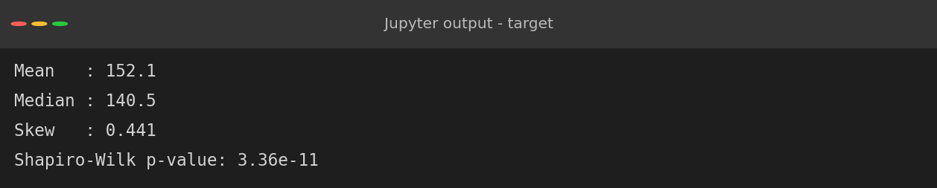
Figure 5: Statistics of the target variable
The mean (152.1) is higher than the median (140.5) and skewness is 0.44, which indicates a mild right tail: a minority of patients progress much faster than the rest. The histogram shows a main peak near 90, a long right shoulder and a small second bump near 270, and the Q-Q plot bends away from the straight reference line at both ends. The Shapiro-Wilk test gives p = 3.4e-11 and rejects exact normality. In practice the deviation is moderate, so linear models remain usable, but errors are likely to be larger for high-progression patients.

5. Distributions of the Predictors
Code 6: Histograms of the nine continuous predictors
feats = ["age", "bmi", "bp", "tc", "ldl", "hdl", "tch", "ltg", "glu"]
fig, axes = plt.subplots(3, 3, figsize=(12, 9))
for a, c in zip(axes.ravel(), feats):
sns.histplot(df[c], kde=True, ax=a, color="#8064a2")
a.set_title(f"{c} (skew {df[c].skew():.2f})", fontsize=11)
plt.suptitle("Distribution of the nine continuous predictors", y=1.0, fontsize=14)
plt.tight_layout(); plt.savefig(f"{FIG}/w2_hist.png", dpi=150)

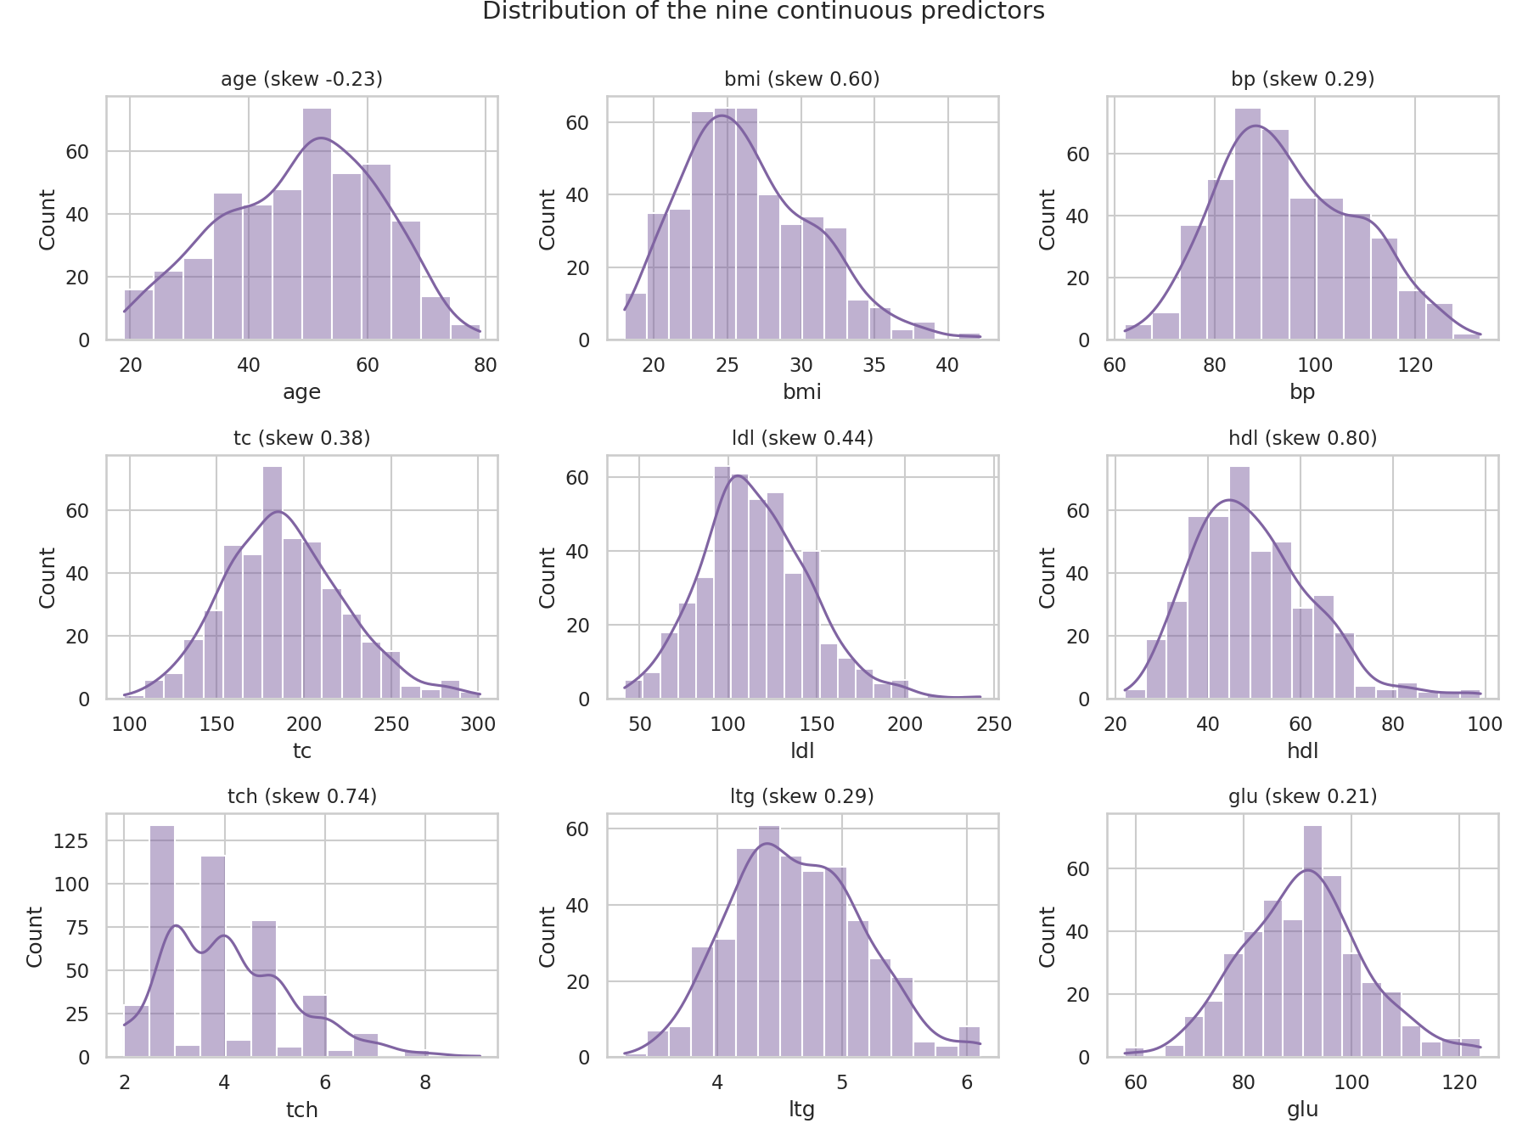
Figure 6: Distributions of the nine continuous predictors
Age is spread broadly with a slight tilt to older patients. BMI, blood pressure and cholesterol measures are close to bell-shaped. HDL and the total/HDL ratio show visible right tails. Triglycerides (ltg) are already on a log scale, which explains why their distribution is tight and symmetric. No variable is bimodal, which suggests the cohort is a single fairly homogeneous population rather than a mix of distinct subgroups.

6. Outliers
Code 7: Counting outliers with the IQR rule
rows = []
for c in feats + ["progression"]:
q1, q3 = df[c].quantile([.25, .75]); i = q3 - q1
n = int(((df[c] < q1 - 1.5 * i) | (df[c] > q3 + 1.5 * i)).sum())
rows.append((c, n, round(n / len(df) * 100, 1)))
out = pd.DataFrame(rows, columns=["feature", "IQR outliers", "percent"])
print(out.to_string(index=False))
fig, ax = plt.subplots(1, 5, figsize=(14, 4))
for a, c in zip(ax, ["bmi", "bp", "tc", "ldl", "glu"]):
sns.boxplot(y=df[c], ax=a, color="#9bbb59"); a.set_title(c)
plt.suptitle("Boxplots of selected predictors")
plt.tight_layout(); plt.savefig(f"{FIG}/w2_box.png", dpi=150)

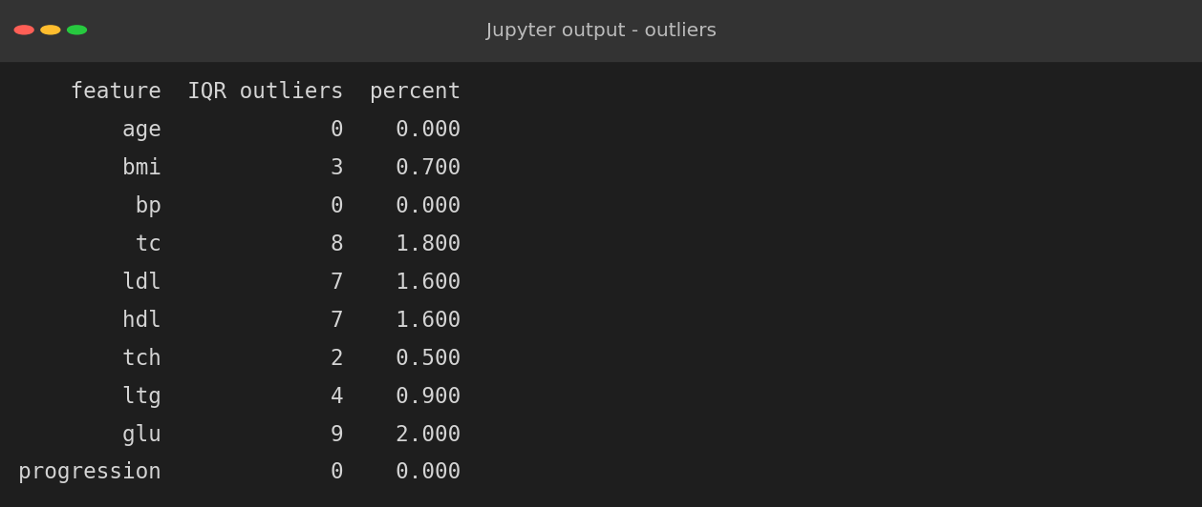
Figure 7: Outlier counts per feature
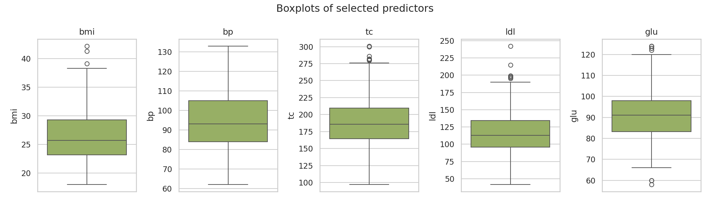
Figure 8: Boxplots of selected predictors
Outliers are rare: at most 2% of the values of any variable (glucose has 9, total cholesterol 8). Neither age, blood pressure nor the target has any. All flagged values are within clinically plausible ranges, for example a glucose of 124 or a BMI of 42.2. They represent real patients at the extremes, not errors, so no records were removed.

7. Feature Transformations and Groupings
Continuous measurements are hard to compare across groups, so four derived columns were created. These are transformations for analysis only and the original columns were left intact:
- age_group: 19-35, 36-50, 51-65 and 66-79 years.
- bmi_cat: Underweight (below 18.5), Normal (18.5 to 25), Overweight (25 to 30) and Obese (above 30), following the WHO thresholds.
- bp_cat: Low, Normal-high and High blood pressure bands.
- risk_high: 1 if progression is in the top quartile, used to highlight the most severe patients.
Code 8: Creating categorical groups and a high-risk flag
df["age_group"] = pd.cut(df["age"], [18, 35, 50, 65, 80],
labels=["19-35", "36-50", "51-65", "66-79"])
df["bmi_cat"] = pd.cut(df["bmi"], [0, 18.5, 25, 30, 100],
labels=["Underweight", "Normal", "Overweight", "Obese"])
df["bp_cat"] = pd.cut(df["bp"], [0, 90, 105, 200],
labels=["Low", "Normal-high", "High"])
df["sex_group"] = df["sex"].map({1: "Group 1", 2: "Group 2"})
df["risk_high"] = (df["progression"] > df["progression"].quantile(.75)).astype(int)
for c in ["age_group", "bmi_cat", "bp_cat", "sex_group"]:
print(df[c].value_counts().sort_index().to_string(), "\n")

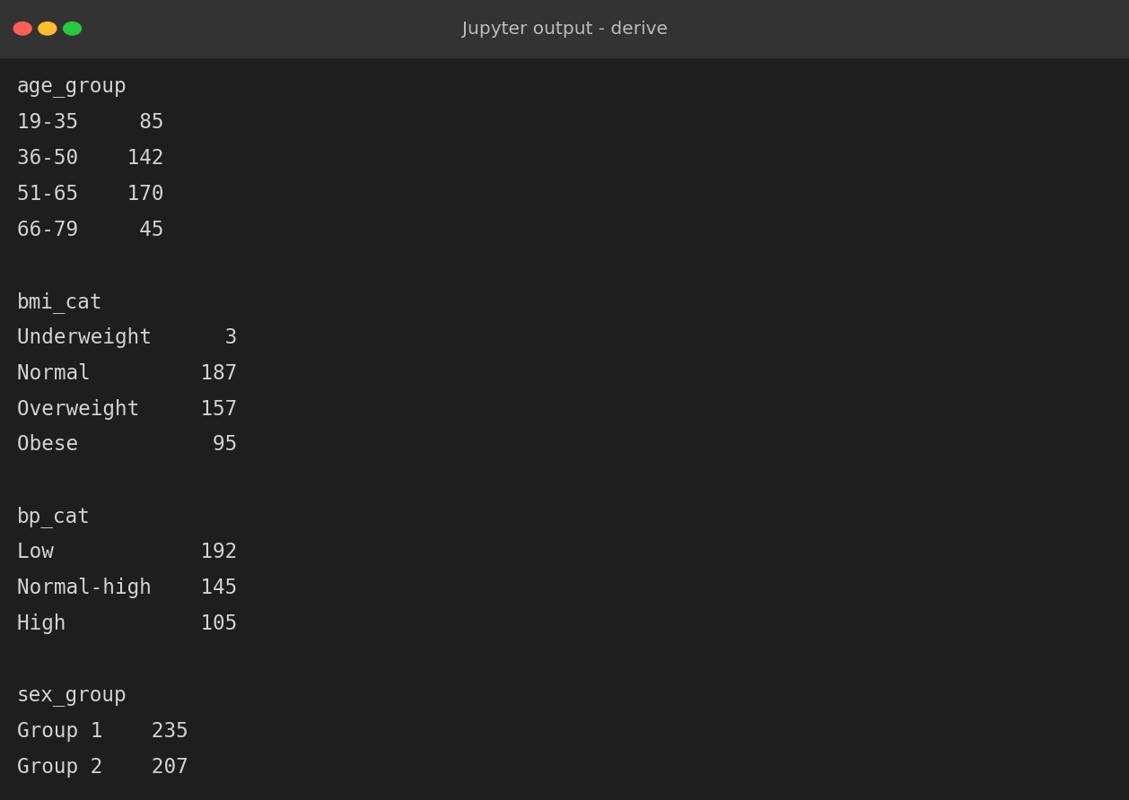
Figure 9: Size of each derived group
Only three patients are underweight, so conclusions about that group are unreliable. The obese group has 95 patients and the overweight group 157, which is a good base for comparison.

8. Correlation Analysis
Code 9: Pearson correlation matrix
num = df[["age", "sex", "bmi", "bp", "tc", "ldl", "hdl", "tch", "ltg", "glu", "progression"]]
corr = num.corr()
plt.figure(figsize=(9.5, 7.5))
mask = np.triu(np.ones_like(corr, dtype=bool))
sns.heatmap(corr, mask=mask, annot=True, fmt=".2f", cmap="coolwarm", center=0,
annot_kws={"size": 8}, cbar_kws={"shrink": .8})
plt.title("Correlation matrix (Pearson)")
plt.tight_layout(); plt.savefig(f"{FIG}/w2_corr.png", dpi=150)
tc = corr["progression"].drop("progression")
print("Correlation with progression:")
print(tc.sort_values(ascending=False).round(3).to_string())

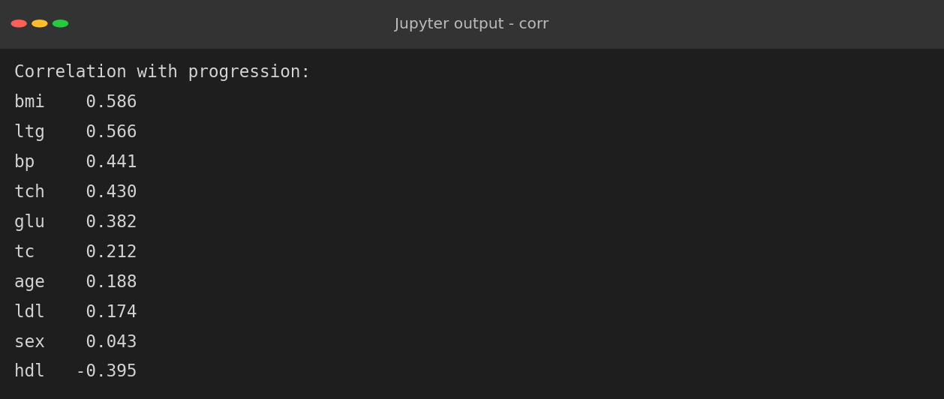
Figure 10: Correlations with the target
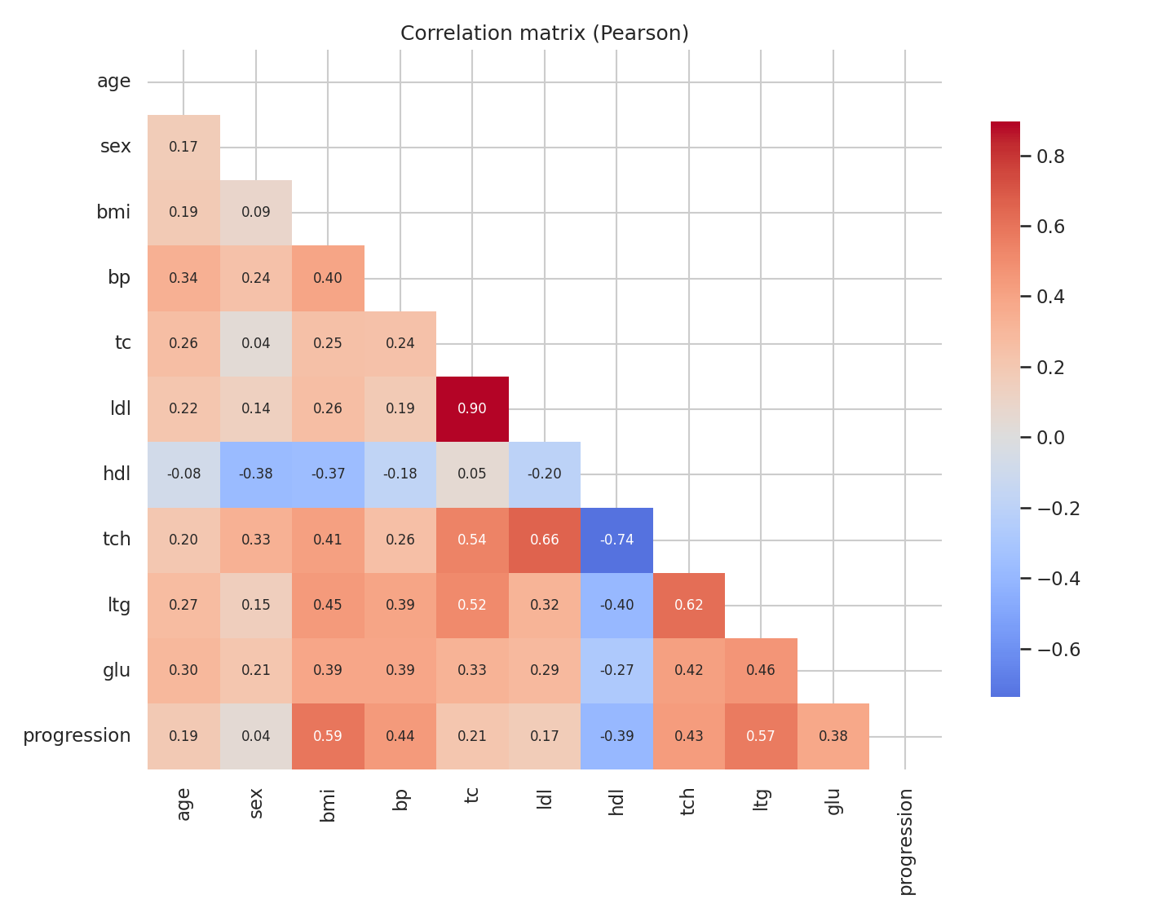
Figure 11: Lower-triangle correlation heatmap of all variables
The heatmap highlights two groups of features.
- Relationships with progression. BMI (0.59) and triglycerides ltg (0.57) have the strongest positive correlations, followed by blood pressure (0.44), the cholesterol ratio (0.43) and glucose (0.38). HDL is the only substantial negative correlation (-0.40), meaning higher 'good cholesterol' goes with slower progression.
- Relationships among predictors. Total cholesterol and LDL are almost the same signal (r = 0.90), and HDL is strongly negatively related to the total/HDL ratio. This is multicollinearity: when two predictors carry the same information, a linear model cannot separate their individual effects.
Code 10: Significance of each correlation
rows = []
for c in feats + ["sex"]:
r, p = stats.pearsonr(df[c], df["progression"])
rows.append((c, r, p))
pt = pd.DataFrame(rows, columns=["feature", "pearson r", "p-value"]).sort_values("pearson r", key=abs, ascending=False)
pt["p-value"] = pt["p-value"].map(lambda v: f"{v:.1e}")
print(pt.to_string(index=False))
colors = ["#c0504d" if v > 0 else "#4f81bd" for v in tc.sort_values().values]
plt.figure(figsize=(8, 5))
tc.sort_values().plot.barh(color=colors)
plt.axvline(0, color="k", lw=.8)
plt.xlabel("Pearson correlation with progression")
plt.title("Which measurements track disease progression?")
plt.tight_layout(); plt.savefig(f"{FIG}/w2_corr_bar.png", dpi=150)

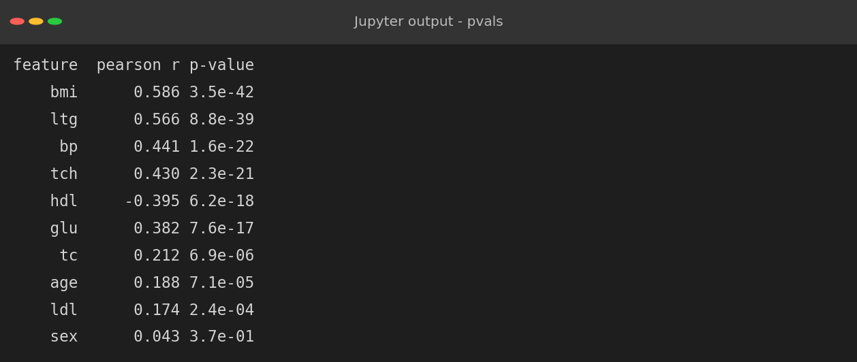
Figure 12: Pearson r and p-values
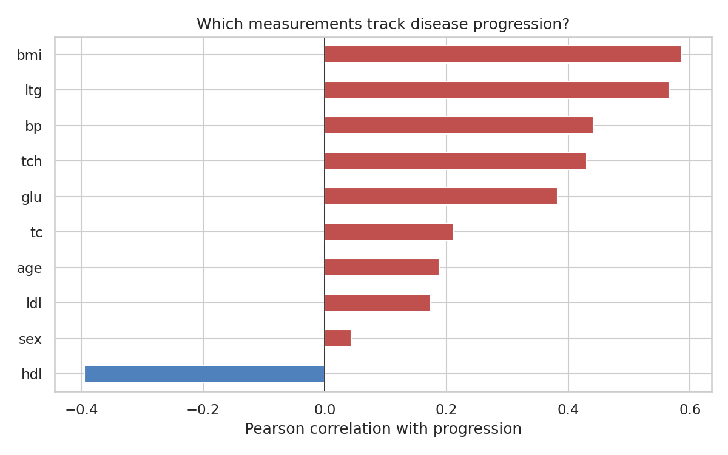
Figure 13: Correlation of each measurement with disease progression
Nine of the ten features have a statistically significant correlation (p < 0.001) with progression. Sex is the exception (r = 0.04, p = 0.37). Note that correlation measures linear association only, and these are observational data, so none of these relationships should be read as proof of cause.

9. Relationships and Scatter Plots
Code 11: Regression plots for the three strongest predictors
fig, ax = plt.subplots(1, 3, figsize=(15, 4.6))
for a, c, col in zip(ax, ["bmi", "ltg", "bp"], ["#c0504d", "#4f81bd", "#9bbb59"]):
sns.regplot(data=df, x=c, y="progression", ax=a, color=col,
scatter_kws={"s": 18, "alpha": .6}, line_kws={"color": "black"})
r = df[c].corr(df["progression"])
a.set_title(f"{c} vs progression (r = {r:.2f})")
plt.tight_layout(); plt.savefig(f"{FIG}/w2_scatter.png", dpi=150)

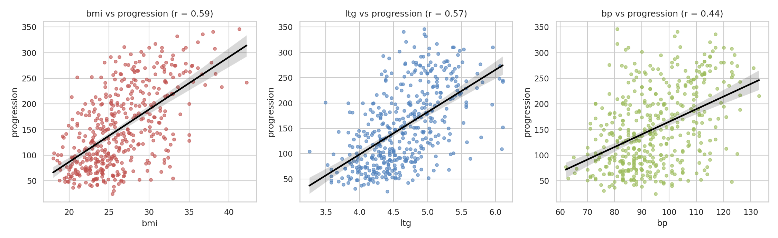
Figure 14: BMI, triglycerides (ltg) and blood pressure versus progression
All three relationships are positive and approximately linear, with wide scatter around the fitted line, which is why the correlations are moderate rather than high. The BMI plot has the cleanest upward trend. The spread of points widens as BMI increases, so predictions would be less precise for heavier patients (heteroscedasticity).

10. Multivariate View
Code 12: Pair plot coloured by risk group
sub = df[["bmi", "ltg", "bp", "progression", "risk_high"]].copy()
sub["Risk"] = sub["risk_high"].map({0: "Lower 75%", 1: "Top 25%"})
g = sns.pairplot(sub.drop(columns="risk_high"), hue="Risk", palette=["#4f81bd", "#c0504d"],
plot_kws={"s": 18, "alpha": .65}, height=2.1, corner=True)
g.figure.suptitle("Pair plot: top-25% progression patients highlighted", y=1.02)
g.savefig(f"{FIG}/w2_pair.png", dpi=140)

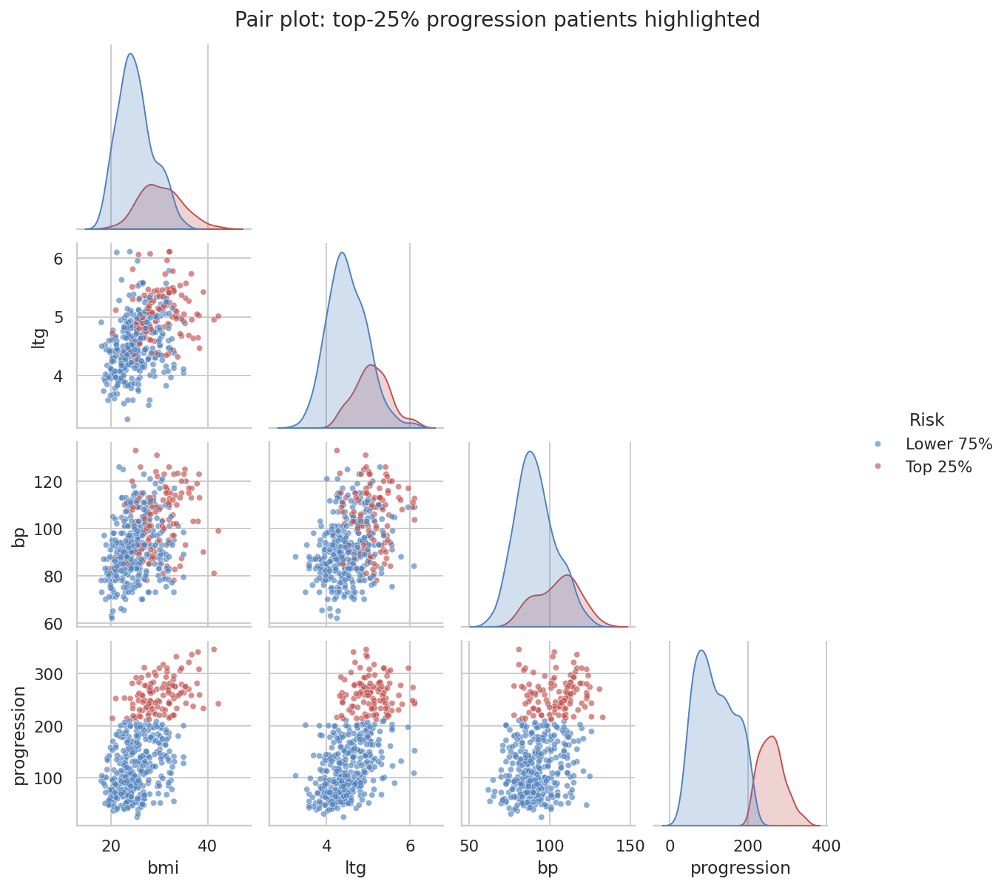
Figure 15: Pair plot of BMI, ltg, blood pressure and progression
The pair plot shows that the top-25% progression patients (red) sit in the upper-right of the BMI versus triglyceride plot: high BMI and high ltg together. Neither variable alone separates the groups cleanly but their combination does a better job, which suggests that a multivariable model will outperform any single predictor.

11. Group Comparisons and Aggregations
Aggregation condenses many rows into group-level summaries. The mean, median and standard deviation of progression were computed for each BMI category and age group.
Code 13: Aggregating progression by BMI category and age group
g1 = df.groupby("bmi_cat", observed=True)["progression"].agg(["count", "mean", "median", "std"])
g2 = df.groupby("age_group", observed=True)["progression"].agg(["count", "mean", "median", "std"])
print(g1.round(1), "\n")
print(g2.round(1))
fig, ax = plt.subplots(1, 3, figsize=(15, 4.6))
sns.boxplot(data=df, x="bmi_cat", y="progression", hue="bmi_cat", ax=ax[0], palette="Set2", legend=False)
ax[0].set_title("Progression by BMI category"); ax[0].set_xlabel("")
sns.violinplot(data=df, x="age_group", y="progression", hue="age_group", ax=ax[1], palette="Set3", legend=False)
ax[1].set_title("Progression by age group"); ax[1].set_xlabel("")
sns.barplot(data=df, x="sex_group", y="progression", hue="sex_group", ax=ax[2], palette="pastel", errorbar="sd", legend=False)
ax[2].set_title("Mean progression by sex group (error bar = SD)"); ax[2].set_xlabel("")
plt.tight_layout(); plt.savefig(f"{FIG}/w2_groups.png", dpi=150)

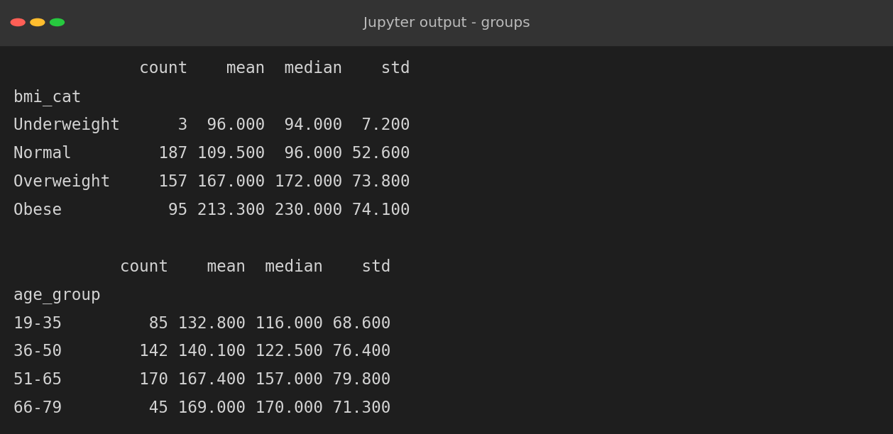
Figure 16: Group aggregations
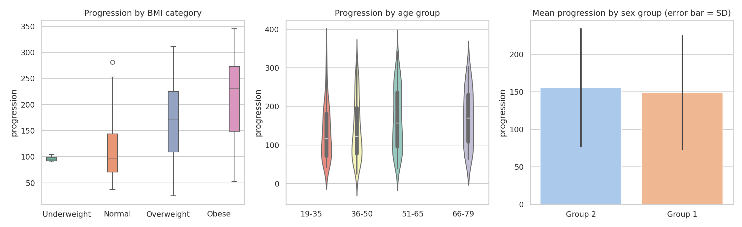
Figure 17: Progression by BMI category, age group and sex group
- BMI: mean progression rises from 109.5 (normal) to 167.0 (overweight) and 213.3 (obese), almost double between the extremes. This is the clearest pattern in the dataset.
- Age: progression increases from 132.8 (19-35) to 169.0 (66-79), but with large overlap between groups (standard deviations near 70 to 80), so age is a weaker discriminator.
- Sex groups: the two groups look alike on the bar chart; the formal test below confirms there is no detectable difference.

12. Two-Factor Interaction
Code 14: Pivot table of age group by BMI category
pv = df.pivot_table(values="progression", index="age_group", columns="bmi_cat",
aggfunc="mean", observed=True)
print(pv.round(1))
plt.figure(figsize=(8, 4.6))
sns.heatmap(pv, annot=True, fmt=".0f", cmap="YlOrRd", cbar_kws={"label": "Mean progression"})
plt.title("Mean progression: age group x BMI category")
plt.ylabel("Age group"); plt.xlabel("BMI category")
plt.tight_layout(); plt.savefig(f"{FIG}/w2_pivot.png", dpi=150)

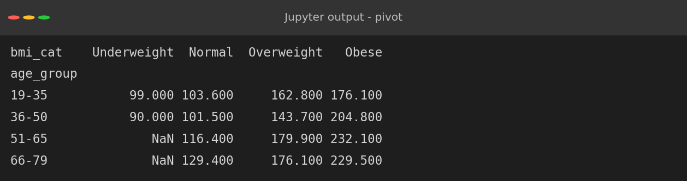
Figure 18: Mean progression by age group and BMI
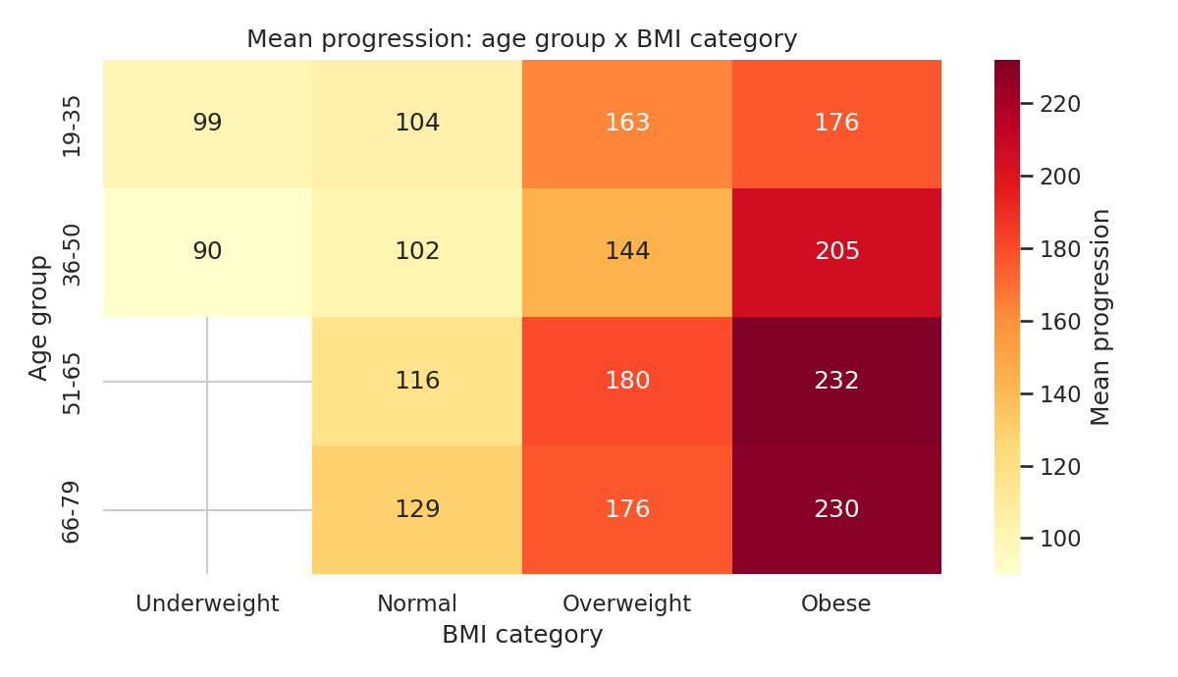
Figure 19: Heatmap of mean progression by age group and BMI category
The heatmap shows that BMI dominates: within every age group, the obese column is the darkest. Age adds to the effect, because obese patients aged 51-65 have the highest mean progression (232.1), compared with 176.1 for obese patients aged 19-35. Conversely, a normal-weight older patient (66-79) still has a low mean of 129.4. Being heavy is the main risk marker and being older amplifies it. The empty cells for underweight patients over 50 are simply due to the lack of such patients in the data.

13. Statistical Testing
Code 15: Hypothesis tests for group differences
a = df.loc[df["sex_group"] == "Group 1", "progression"]
b = df.loc[df["sex_group"] == "Group 2", "progression"]
t = stats.ttest_ind(a, b, equal_var=False)
print(f"Welch t-test (sex groups): t = {t.statistic:.2f}, p = {t.pvalue:.3f}")
cats = [g["progression"].values for _, g in df.groupby("bmi_cat", observed=True)]
f = stats.f_oneway(*cats)
print(f"ANOVA (BMI categories) : F = {f.statistic:.2f}, p = {f.pvalue:.1e}")
hdl_hi = df[df["hdl"] > df["hdl"].median()]["progression"]
hdl_lo = df[df["hdl"] <= df["hdl"].median()]["progression"]
t2 = stats.ttest_ind(hdl_hi, hdl_lo, equal_var=False)
print(f"Welch t-test (high vs low HDL): t = {t2.statistic:.2f}, p = {t2.pvalue:.1e}")
print(f"Mean progression, high HDL: {hdl_hi.mean():.1f} low HDL: {hdl_lo.mean():.1f}")

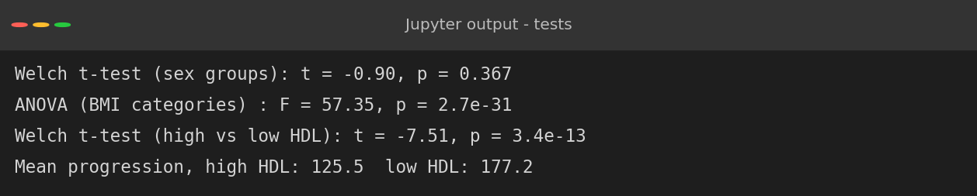
Figure 20: Welch t-tests and ANOVA
Table 2: Summary of hypothesis tests
Question | Test | Result | Conclusion
Do sex groups differ? | Welch t-test | p = 0.367 | No significant difference
Do BMI categories differ? | One-way ANOVA | F = 57.4, p = 2.7e-31 | Highly significant
High vs low HDL | Welch t-test | p = 3.4e-13 | Low HDL: 177.2 vs 125.5

The tests confirm what the plots suggested: BMI category and HDL level are linked to progression with overwhelming statistical evidence, while sex is not. The HDL result is notable because patients with below-median HDL progress, on average, 52 points more (177.2 versus 125.5).

14. Lipid Measurements
Code 16: Relationship between cholesterol variables
fig, ax = plt.subplots(1, 2, figsize=(12, 4.8))
sns.scatterplot(data=df, x="tc", y="ldl", hue="progression", palette="viridis", ax=ax[0], s=30)
ax[0].set_title(f"Total cholesterol vs LDL (r = {df['tc'].corr(df['ldl']):.2f})")
sns.scatterplot(data=df, x="hdl", y="tch", hue="progression", palette="viridis", ax=ax[1], s=30)
ax[1].set_title(f"HDL vs total/HDL ratio (r = {df['hdl'].corr(df['tch']):.2f})")
plt.tight_layout(); plt.savefig(f"{FIG}/w2_lipids.png", dpi=150)

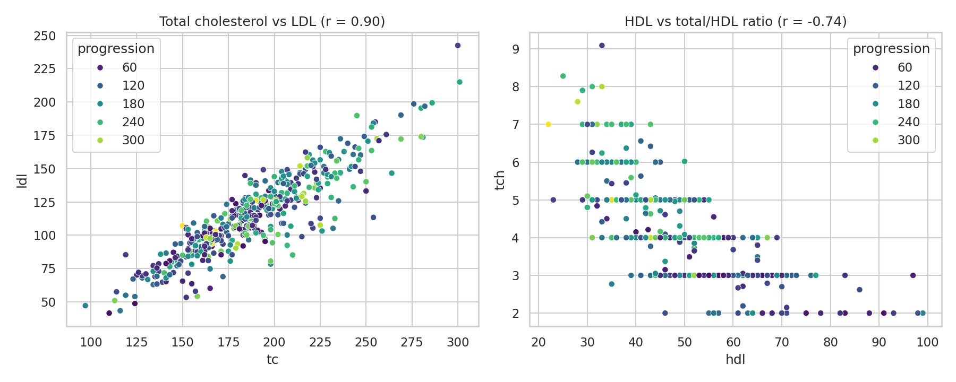
Figure 21: Total cholesterol versus LDL (left) and HDL versus total/HDL ratio (right), coloured by progression
Total cholesterol and LDL lie nearly on a line (r = 0.90), confirming that they are redundant. The right panel shows that low HDL combined with a high ratio is associated with the brighter (higher-progression) points. This is why the ratio, which combines two lipid measures, is a more informative feature than total cholesterol alone.

15. Key Insights
1. BMI is the strongest single indicator. Mean progression nearly doubles from normal weight to obese (109.5 to 213.3).
2. Blood lipids matter. Triglycerides (ltg) are positively related and HDL negatively related to progression.
3. Variables work together. The combination of high BMI and high triglycerides separates fast progressors better than either alone.
4. Age and sex are weak. Age adds a modest increase while sex shows no significant effect.
5. Redundancy exists. Total cholesterol and LDL are almost interchangeable, so models should regularise or drop one of them.
6. Data quality is high. No missing values, no duplicates, and the few extreme values are plausible.

16. Limitations
- Correlation is not causation: this is observational data with no control over confounders.
- The sample is small (442) and the demographic origin is not described, so findings may not generalise.
- Pearson correlation captures only linear patterns; nonlinear effects can be missed.
- Some groups are tiny (3 underweight patients), so their statistics must not be over-interpreted.
- Many tests were run without correction for multiple comparisons, although the key p-values are far below any reasonable threshold.

17. Conclusion
The exploratory analysis shows a coherent story: patients with high BMI, high triglycerides, elevated blood pressure and low HDL cholesterol tend to progress faster, with BMI as the single strongest marker, while age plays a supporting role and sex plays no detectable role. The data is clean, with mild skew and multicollinearity between cholesterol measures. These insights guide later modelling: regularised linear models are an appropriate starting point, interaction effects such as BMI with age are worth testing, and the redundant cholesterol features should be handled deliberately. The same dataset is carried forward into the capstone project.

18. References
- Efron, B., Hastie, T., Johnstone, I. and Tibshirani, R. (2004). Least Angle Regression. The Annals of Statistics, 32(2), 407-499.
- Waskom, M. (2021). Seaborn: statistical data visualization. Journal of Open Source Software, 6(60), 3021.
- Hunter, J. D. (2007). Matplotlib: A 2D graphics environment. Computing in Science and Engineering, 9(3), 90-95.
- Virtanen, P. et al. (2020). SciPy 1.0: fundamental algorithms for scientific computing in Python. Nature Methods, 17, 261-272.

